**Lab 5:**

**Objectives:**

* Implement of Boolean function using logic gates
* Combinational circuits
* Design procedures
* Code converter
* BCD numbers

**Task 1:**

An ABCD-to-seven-segment decoder is a combinational circuit that converts a decimal digit in BCD to an appropriate code for the selection of segments in an indicator used to display the decimal digit in a familiar form. The seven outputs of the decoder (a, b, c, d, e, f, g) select the corresponding segments in the display, as shown in Fig. (a) . The alphabetic display chosen to represent the decimal digit is shown in Fig. (b) . Using a truth table and Karnaugh maps , design the BCD-to-seven-segment decoder using a minimum number of gates. The six invalid combinations should result in a blank display

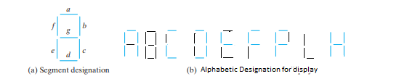

**Task 2:**

Two circuits are given below, find out its functions. Function may be expressed as

* Boolean function
* Truth table

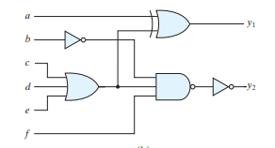

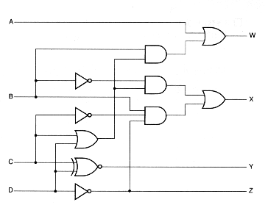

**Task 3:**

Design a circuit to convert “BCD” code to “Excess5” code. Invalid combination will be don’t cares.